Software Engineer
The software engineer implements the feature by writing the code that tracks when a user stops watching a movie and stores that state. They build the logic to trigger reminders, integrate it with the notification system, and ensure the feature works seamlessly across devices and platforms.
Software Architect
The architect designs the overall technical framework for the feature. They decide how the reminder system interacts with existing services, databases, and APIs, ensuring scalability, security, and alignment with the platform’s long-term architecture.
Product Manager
The product manager defines the vision and requirements for the feature. They gather user feedback, analyze market needs, and decide how reminders should be delivered (e.g., push notifications, emails, or in-app alerts). They balance user experience with business goals and communicate priorities to the development team.
Quality Assurance (QA) Engineer
The QA engineer tests the feature thoroughly before release. They create test cases to confirm reminders trigger correctly, verify functionality across devices, and check for bugs or performance issues. They also test edge cases, such as when users finish movies offline or clear their watch history.
Technical Support Engineer
After launch, the technical support engineer assists users who encounter problems with the feature. They troubleshoot issues, provide guidance, and escalate bugs to the engineering team when necessary. Their role ensures users have a smooth experience and feel supported.
Project Manager
The project manager oversees the entire process, coordinating between engineers, architects, QA, product managers, and support teams. They manage timelines, allocate resources, track progress, and ensure the feature is delivered on schedule. They also facilitate communication across departments to keep everyone aligned.

Here’s the content distilled into clear bullet points for easy review:

Getting Started with Python
- Python is beginner-friendly and widely used for web development, data analysis, machine learning, and more.
- You need to install Python and an IDE to practice coding.
- This course provides an introduction, not full developer-level expertise.
Downloading and Installing Python
- Python uses an interpreter to execute code line by line.
- Save code in .py files and run with the interpreter.
- Check installation with python --version in the command line.
- Download Python from the official site.
Python Interactive Mode
- Interactive mode allows experimenting directly in the interpreter.
- Launch with python or python3 in Terminal/Command Prompt.
- Enter code at the >>> prompt.
- Exit with exit().
IDEs for Python Development
- PyCharm: Free community edition, professional features.
- Visual Studio Code: Free, open-source, supports multiple languages.
- AWS Cloud9: Browser-based IDE with built-in terminal, debugger, and cloud integration.
Problem-Solving Process
- Understand the problem: Define goals, requirements, and expected outcomes.
- Identify high-level steps: Outline major tasks as a roadmap.
- Break down each step: Divide into smaller, manageable substeps.
- Use flowcharts or lists: Visualize logic and workflow.
- Focus on one piece at a time: Avoid overwhelm by tackling substeps individually.
- Write pseudocode or comments: Outline logic before coding.
- Test incrementally: Verify each substep before moving on.
- Build incrementally: Integrate substeps gradually.
- Refine and optimize: Improve clarity and efficiency.
- Test thoroughly: Use varied inputs, including incorrect ones.
- Document your solution: Add comments and explanations.
- Reflect and learn: Review what worked and what can improve.

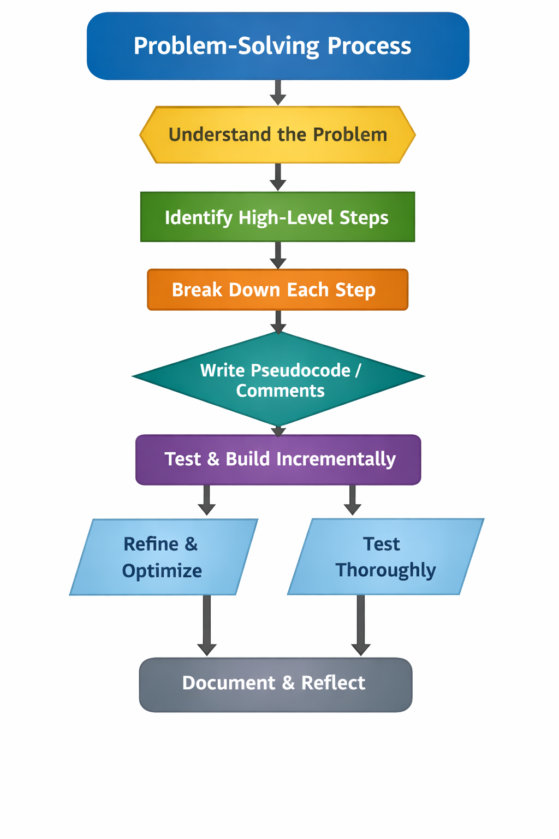
Variables and Conditionals
Variables
A variable is a place where you assign a value that might change. The fact that it might change makes it a variable. You can now refer to the variable elsewhere in your application, instead of referring to the value that’s assigned to the variable.
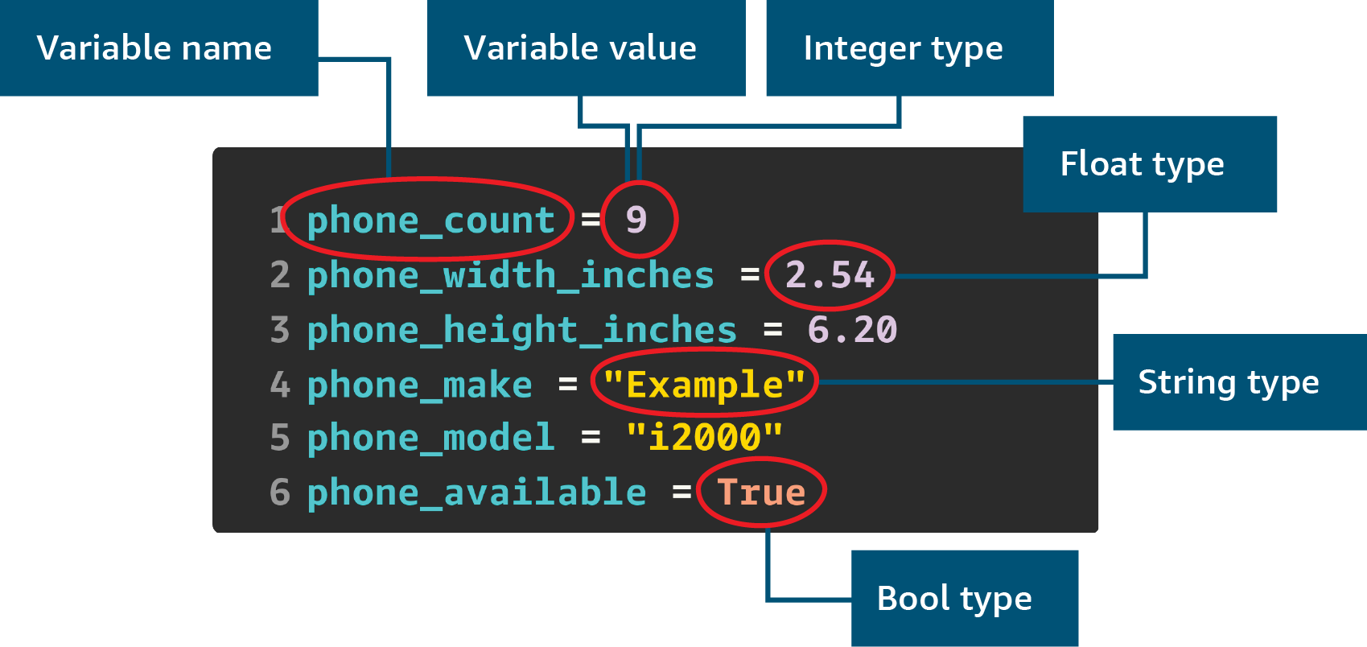
Image description for accessibility: In the code sample in the previous image, phone_count is a variable name and its assigned value is the numeral 9. A variable value that’s a whole number is an integer data type. A variable called phone_width_inches is assigned a value of 2.54. A decimal number is a float data type. A variable called phone_make is assigned a value of "Example". The pair of straight quotation marks that enclose the word Example indicate that it’s a string data type. A variable called phone_available has an assigned value of True, which is a Boolean (or Bool) data type. The Bool data type has a value of either True or False, which is capitalized to indicate that it’s a Boolean value and not a string. End image description.
You assign a value to a variable by using the equal sign (=). After you assign a value, you can refer to the variable name elsewhere in your code or assign a new value to the variable.The values that you assign to the variables can be of different types. A type determines the type of data you’re storing and the operations that you can perform on that data.The previous sample code uses four different data types:
- The integer type (or int) is used for whole numbers.
- The float type is a number that includes a decimal portion.
- The string type stores text.
- The bool (or Boolean) type can be true or false.
You can perform different operations on different types. For example, you can use an asterisk (*) as a multiplication operator to multiply two int or float types. The following example has two lines of code with two different operations. The first line of code uses an asterisk (*) to multiply two values. The second line uses a plus sign (+) to combine (or concatenate) strings.
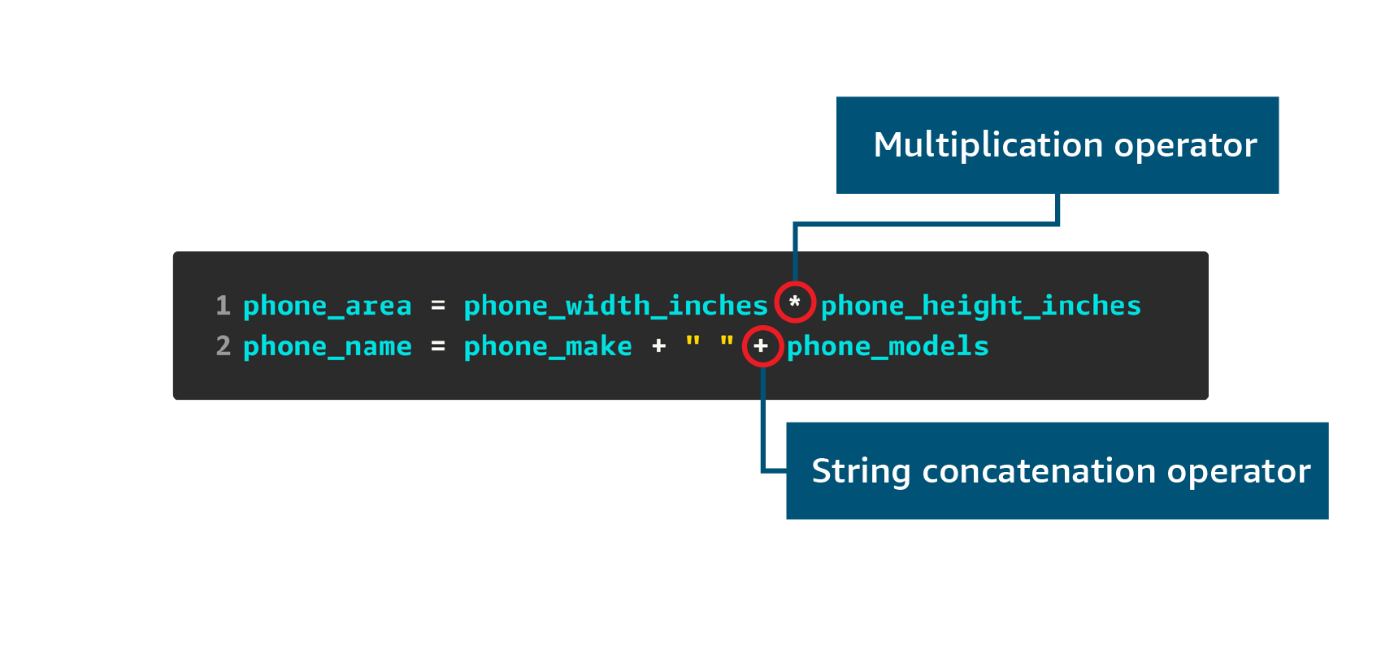
Image description for accessibility: The code sample in the previous image includes two different operators. The first line uses an asterisk (*) as a multiplication operator to multiply two float variables, phone_width_inches and phone_height_inches. The second line uses plus signs (+) to concatenate two different string variables, phone_make and phone_model, with a blank space (represented as pair of straight quotation marks that enclose a blank space) in between the string variables. End image description.
Moving on to a more advanced topic: formatting strings. To build a formatted string from variables in Python, use the lowercase f prefix at the beginning of the quoted string. This formatting uses a feature of Python that’s called formatted string literals (or f-strings), which is a shorthand way of building a string. The braces and variable names will be replaced by their values.
The following code example includes f-strings for formatting strings. You can do additional formatting by including some settings after a colon (:). For example, the second line of the following code uses .5 after the colon to set a precision, which is the number of columns after the decimal point you want to display.
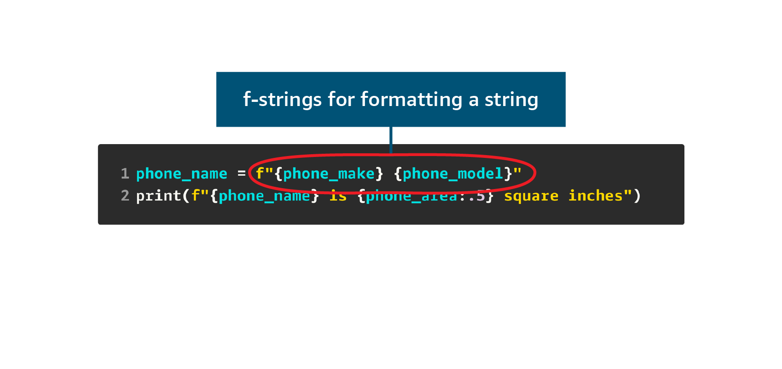
Image description for accessibility: The code sample in the previous image uses the lowercase f character to format a string. The f character is placed directly before the formatted string, which is enclosed in straight quotation marks, as follows: phone_name = f"{phone_make} space {phone_model}". End image description.
For more information, see Formatted String Literals in the Python documentation.
Conditionals
In Python, conditionals are represented by using if/else statements. When you set up an if statement, you evaluate an expression. If that expression is true, the code block associated with the if statement runs. If the expression is false, then the code block associated with the conditional is skipped.
The following sample code evaluates the “message_one != message_two” expression, where the “!=” is a does not equal comparison. Whereas “==” is the equals comparison operator. If the expression evaluates to true, the first print statement runs. If the expression is not true, you enter the else block and the second print statement runs.

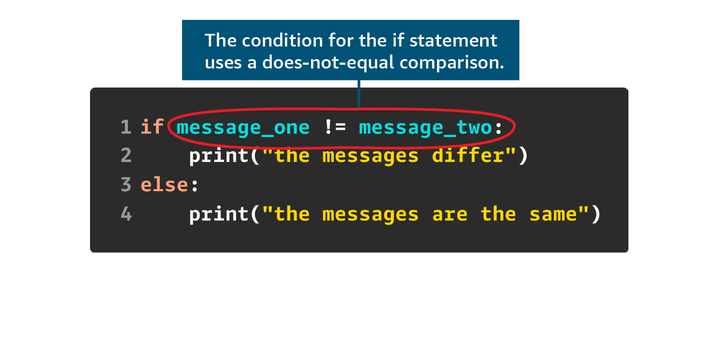
Here’s a concise bullet-point summary of the key concepts from the reading:

Functions
- Functions are reusable blocks of code that run only when called.
- Parameters allow functions to accept input; return statements send output back.
- Functions improve code organization, readability, and maintainability.
- They simplify debugging and testing by isolating logic.
- Variables inside functions have local scope, preventing naming conflicts.
- Defined using def keyword followed by function name and optional parameters.
Example:
def square_number(number):
return number**2

Lists
- Lists store ordered collections of items and are mutable.
- Created using square brackets [] with comma-separated values.
- Elements accessed via indexing (starting at 0); negative indices count from the end.
- Common list methods:
  - append(), insert(), remove(), pop()
  - len(), sort(), reverse(), index(), count()
Example:
colors = ['Red', 'Orange', 'Yellow']
print(colors[0]) # Output: Red

Dictionaries
- Dictionaries store data in key-value pairs.
- Created using curly braces {} with keys and values separated by colons.
- Access values using keys inside square brackets.
- Useful for fast lookups using descriptive labels.
Example:
info = {
'ImageId': 'ami-069eb5ebcbc6b0f91',
'InstanceId': 'i-0c5c2bb0a41ef1b29'
}
print(info['ImageId']) # Output: ami-069eb5ebcbc6b0f91

Here’s a comparison table that highlights the key differences between lists and dictionaries in Python:
Feature | Lists | Dictionaries
Structure | Ordered collection of items | Unordered collection of key-value pairs
Syntax | [] square brackets | {} curly braces
Access Method | By index (e.g., colors[0]) | By key (e.g., info['ImageId'])
Mutability | Mutable (can add, remove, or change items) | Mutable (can add, remove, or change key-value pairs)
Use Case | Best for sequences and ordered data | Best for labeled data and fast lookups
Common Methods | append(), insert(), remove(), pop(), sort() | get(), keys(), values(), items(), update()
Duplicates Allowed | Yes (e.g., [1, 2, 2]) | Keys must be unique; values can repeat
Indexing | Integer-based indexing | Key-based indexing
Example | colors = ['Red', 'Blue'] | info = {'ImageId': 'ami-123', 'Type': 'm5.large'}

Putting it all together
Loops
Some operations need to be done multiple times. For example, say that you’re writing code to send 50 emails. You can write the 50 emails in a loop.
In the first for loop example, the loop body will be run for every iteration of the loop. A for loop can use a range function to create a range of numbers to iterate over. Each iteration of the loop uses the next number in the range, this number is made available in the i variable. This loops prints the numbers from 0 to 9.
You can also use the types that you’re familiar with in a for loop. The following examples use lists and dictionaries instead of using a range object.
The second example uses the colors list in the for loop. Each iteration of the loop sets the value of the c variable with the items in the list.
The third example uses a dictionary that maps colors to hexadecimal (hex) values. Each iteration of the loop sets the k variable to the keys in the dictionary.
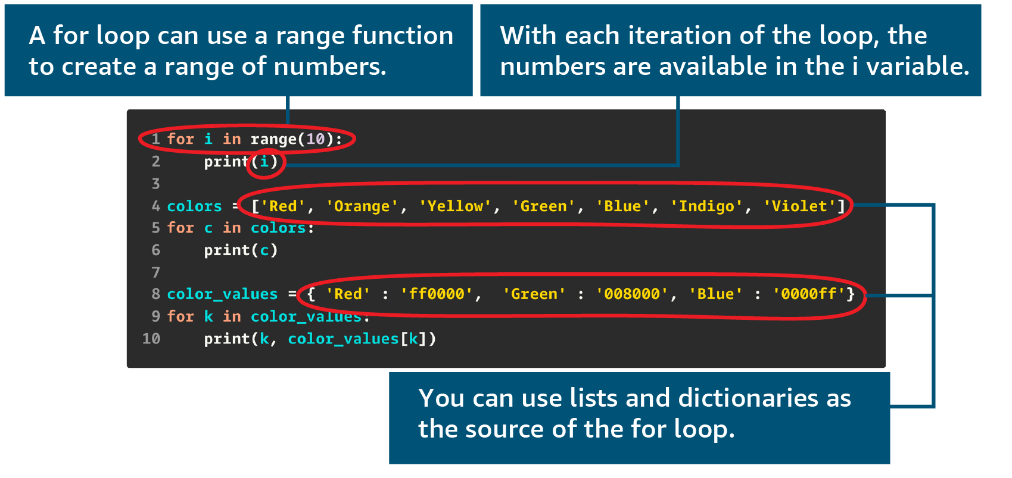
Image description for accessibility: The code sets up a for loop and a variable called i by using the following statement: for i in range(10). For loops can use a range function to create a range of numbers. In this for loop, each number in the loop’s range is available in the i variable with each iteration of the loop. The next two examples use a list called colors and a dictionary called color_values to show that you can use lists and dictionaries as the source of a for loop. End image description.
A while loop has a condition that must be true for the loop to keep iterating. This condition is evaluated at the beginning of every loop. If the condition is false, it exits the loop.
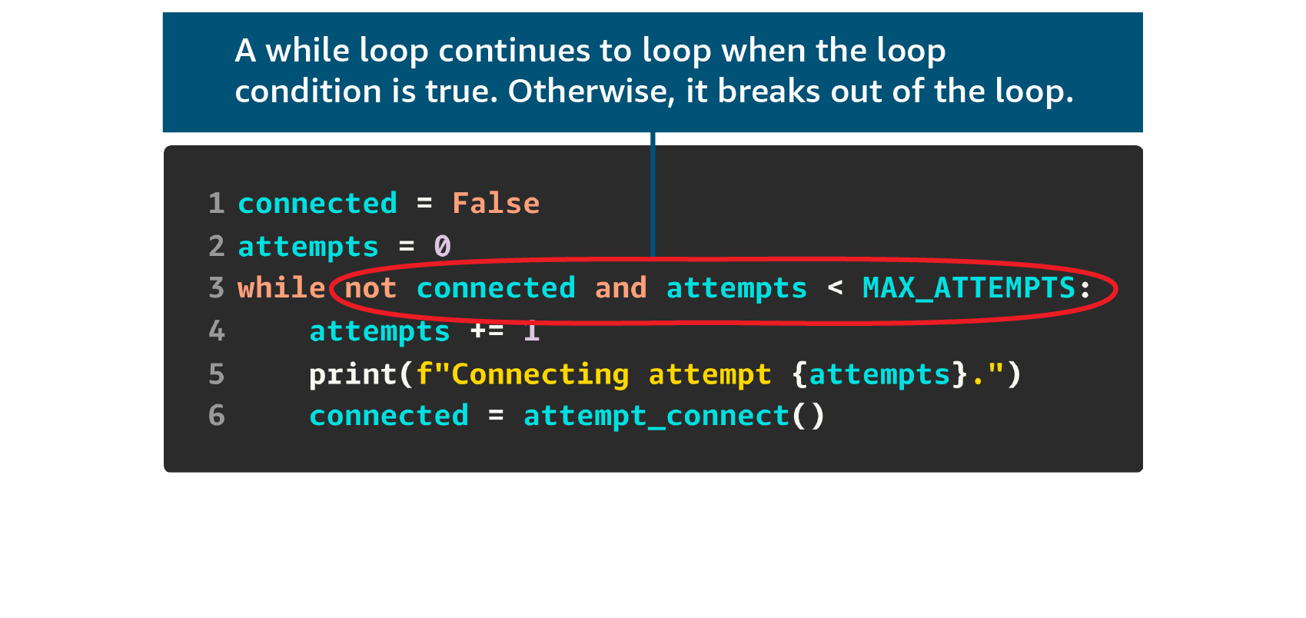
Image description for accessibility: The code defines a while loop with the following statement: while not connected and attempts < MAX_ATTEMPTS. A while loop continues looping when the loop condition is true, or it breaks out of the loop. End image description.
List comprehensions
The following example is a list comprehension. Use list comprehensions to construct a new list, and they use a syntax that’s similar to a for loop.
A list comprehension uses square brackets ([]), which is like how a list is initialized. The next part is an expression that runs for every iteration of the for clause.
The first example calls the upper function to uppercase the text in the c variable. This expression is used to populate the new list.
The second example includes an if condition to restrict the items in the new list. This example tests the c variable so that it only include the colors that start with the uppercase letter G.
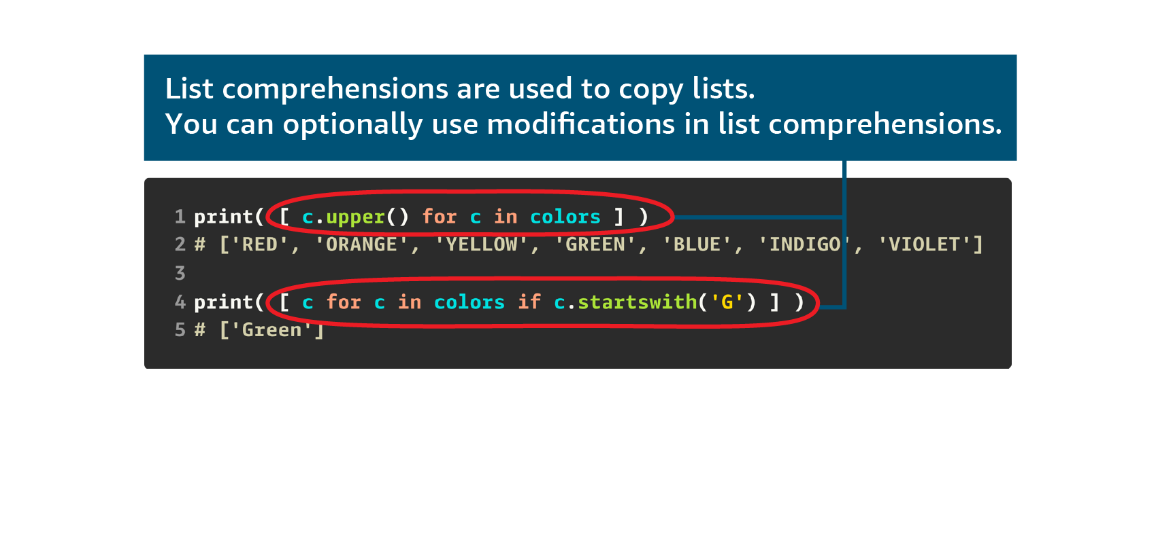
Image description for accessibility: The image shows two list comprehensions that are constructed by using square brackets and for statements. The first list comprehension is defined as follows: [c.upper() for c in colors]. The second list comprehension is defined as follows: [c for c in colors if.startswith(‘G’)]. List comprehensions are used to copy lists, optionally with some modifications. End image description.
Writing a script
This section brings all the Python concepts together through a script for a simple game. The game chooses a random country. The player has two guesses to guess the population of the country. After the player makes two guesses, the game asks them to name the random country.
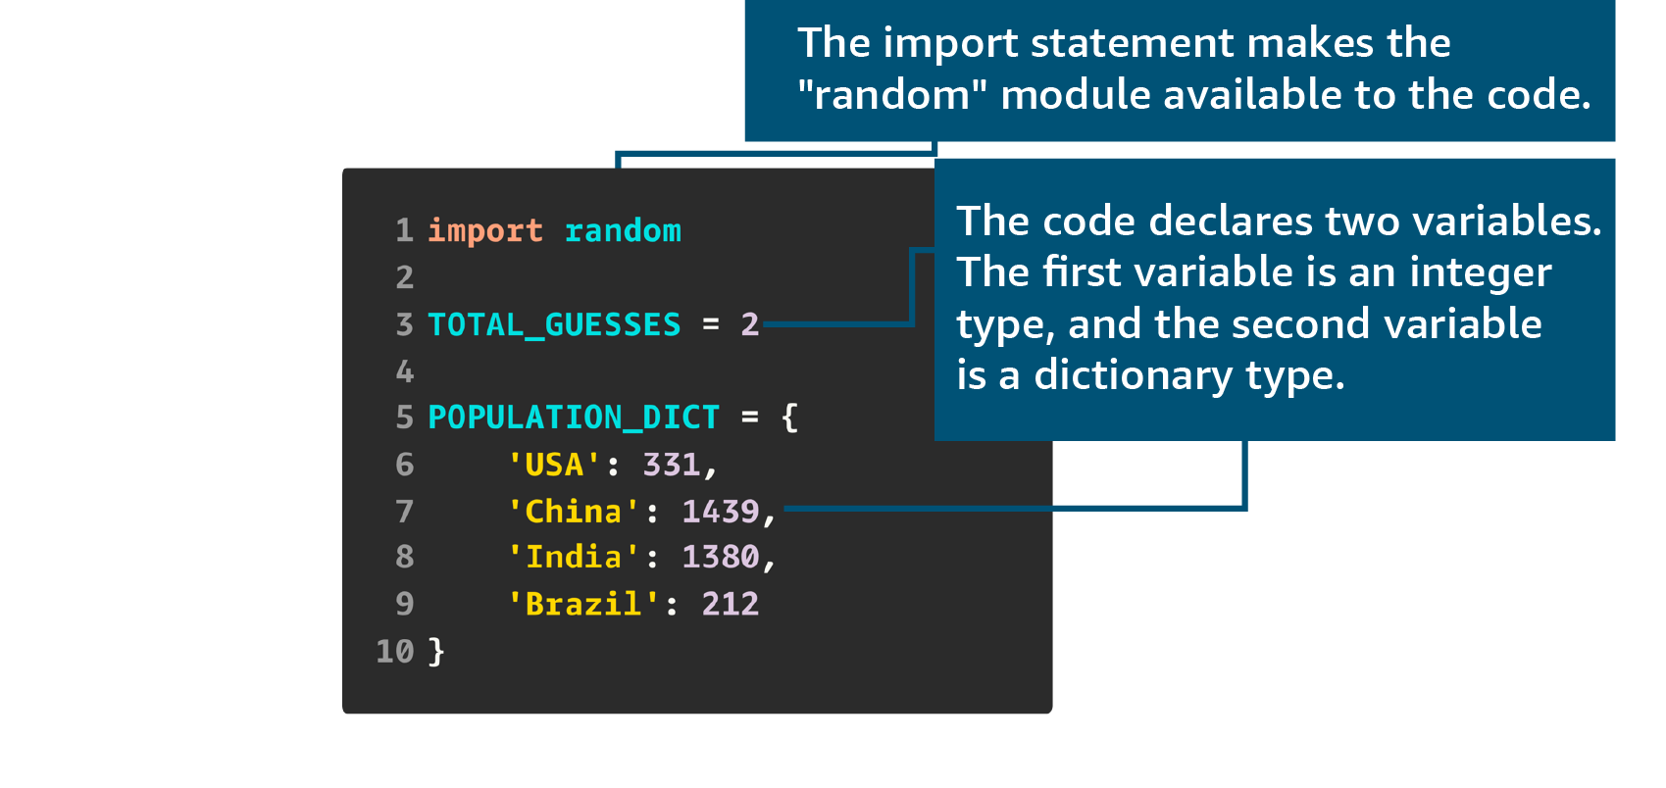
Image description for accessibility: In the code example, the import random statement makes the random Python module available to the code. The code then declares two variables: TOTAL_GUESSES is an integer type, and POPULATION_DICT is a dictionary type. End image description.
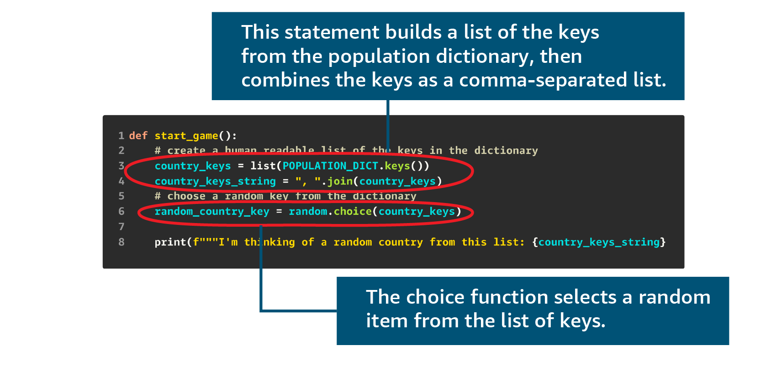
Image description for accessibility: A line of code defines the country_keys variable as follows: country_keys = list(POPULATION_DICT.keys()). This code uses the list method to build a list of keys from the POPULATION_DICT dictionary. The next line of code defines the country_keys_string variable as follows: country_keys_string = “, ”.join(country_keys). This code uses the join method to combine the keys into a comma-separated list. A third line of code defines the random_country_key variable as follows: random_country_key = random.choice(country_keys). This code uses the choice method of the random module to select a random item from the list of country keys. End image description
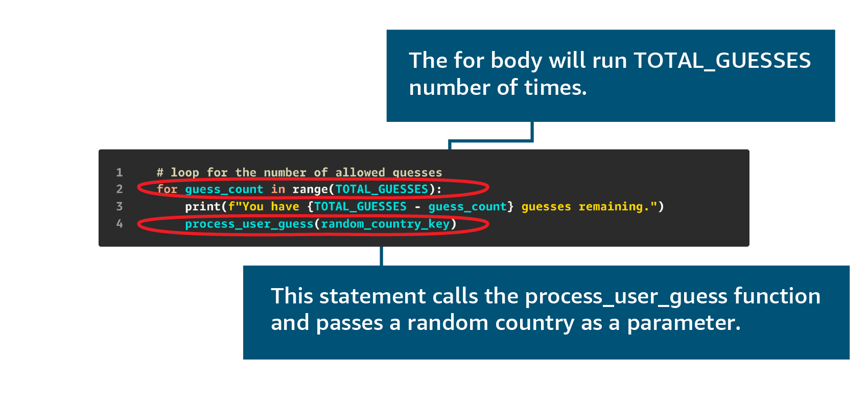
Image description for accessibility: The code sets up a for loop as follows: for guess_count in range(TOTAL_GUESSES):. This code means that the body of the loop will run as many times as the integer that’s assigned to the TOTAL_GUESSES variable. The loop body also includes the following line: process_user_guess(random_country_key). This code calls the process_user_guess function, which is defined later, and passes a random country as a parameter. End image description.
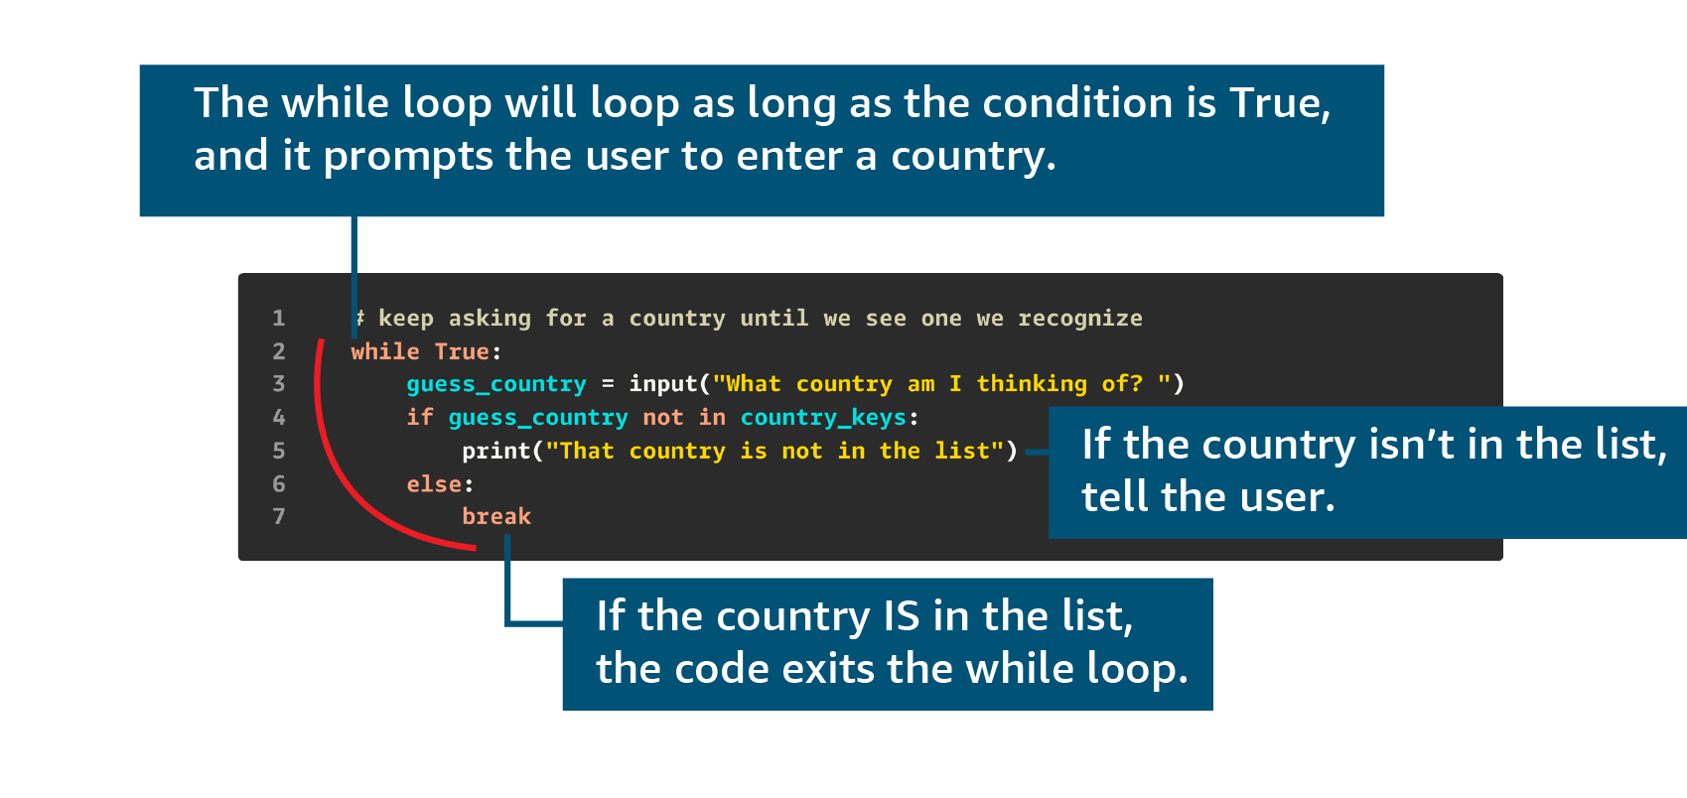
Image description for accessibility: In the code, a while loop is set up with the following statement: while True:. This code means that the loop will run as long as the True condition is met. In the body of the while loop, the guess_country variable is so it prompts the user to input a country name. The code then sets up an if statement as follows: if guess_country not in country_keys:. This if block checks if the user’s guessed country is in the list. If the country isn’t in the list, the user is notified. The while loop ends with an else block that’s defined with the word break. This code means that if the user’s guess country is in the list, the game can exit the while loop. End image description.
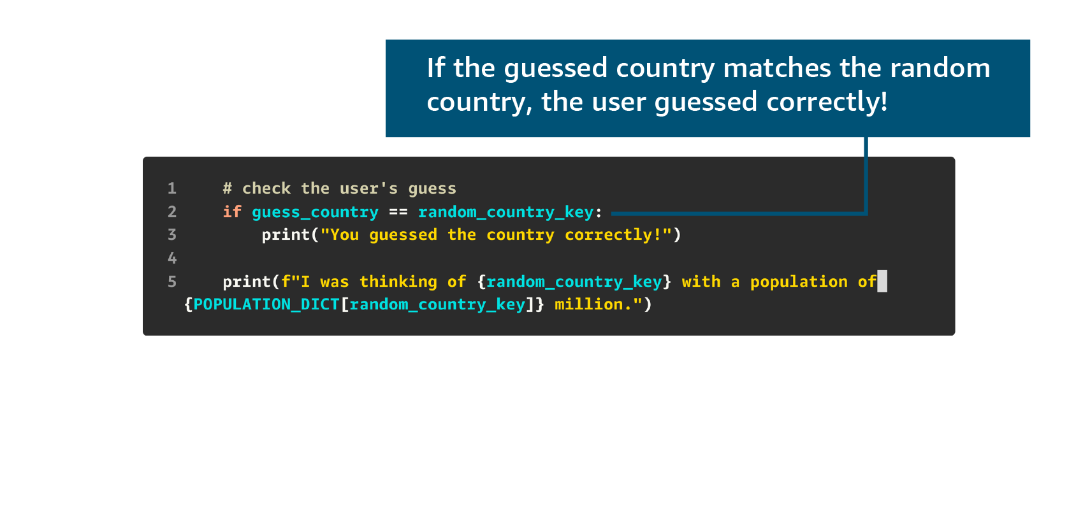
Image description for accessibility: The code sets up an if block as follows: if guess_country == random_country_key:. This if block checks if the user’s guessed country matches the random country. If so, the user is told that they guessed correctly. End image description.
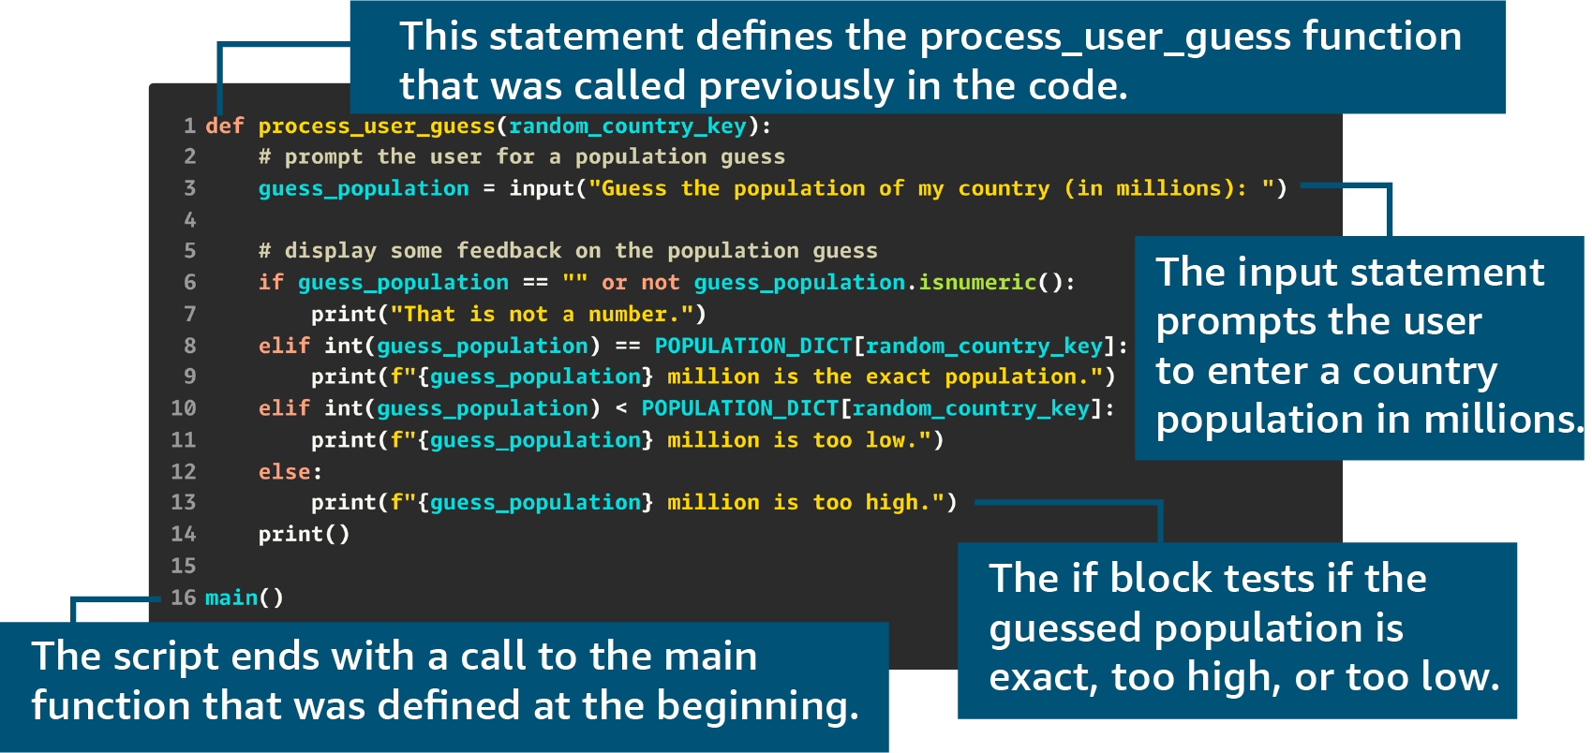
Image description for accessibility: The code shows setting up a function definition with the following statement: def process_user_guess(random_country_key):. This function was called in an earlier code example. Next, the guess_population variable is defined so it prompts the user to input a population in millions. Then, an if block uses an if statement to check if the input is a number. Next, the if block uses series of elif statements and an else statement to test if the user’s guessed population is exact, too high, or too low. The game script ends with the following function call: main(). This code calls the main function that was defined at the beginning of the script. End image description.
Finally, the main function displays a welcome message and calls the start_game() function.
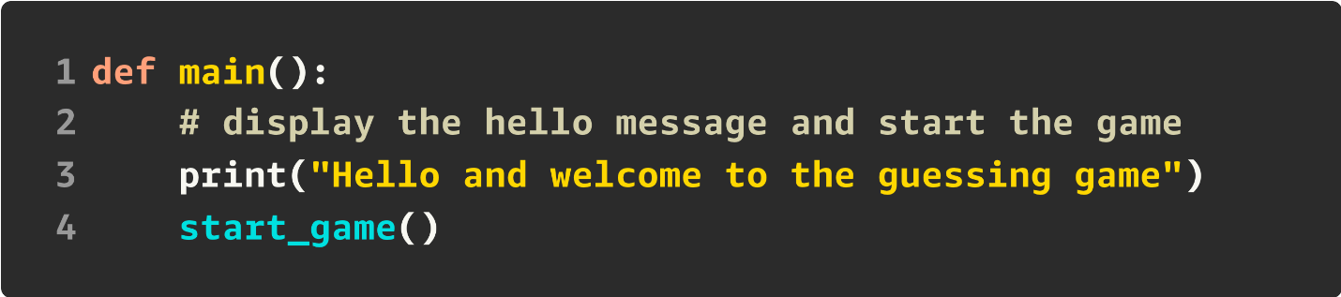

Here’s a clean bullet-point summary of the Python Hands-On concepts:

Variables and Types
- Variables store values that can change during program execution.
- Common types:
  - int → whole numbers
  - float → decimal numbers
  - str → text (strings)
  - bool → True/False values
- Example:
- phone_count = 9
- phone_width_inches = 2.54
- phone_make = "Example"
- phone_available = True

Conditionals
- Used to control program flow based on conditions.
- if, elif, and else decide which block of code runs.
- Example:
- if number_one > number_two:
- print("number one is greater")

Functions
- Named blocks of reusable code for specific tasks.
- Defined using def keyword.
- Can take parameters and return values.
- Example (correct square function):
- def square_number(number):
- return number ** 2

Lists
- Ordered, mutable collections of items.
- Created with square brackets [].
- Support indexing, slicing, and methods like append(), insert(), remove(), pop().
- Example:
- colors = ['Red', 'Orange', 'Yellow']
- print(colors[0]) # Red

Dictionaries
- Store data in key-value pairs.
- Created with curly braces {}.
- Access values using keys.
- Example:
- info = {'ImageId': 'ami-123', 'Type': 'm5.large'}
- print(info['ImageId'])

Loops
- Repeat operations multiple times.
- for loop commonly used with range() or data structures.
- Example:
- for i in range(5):
- print(i)

List Comprehensions
- Concise way to build new lists.
- Syntax resembles a for loop inside brackets.
- Example:
- [c.upper() for c in colors] # Uppercase all colors
- [c for c in colors if c.startswith('G')] # Colors starting with G

Here’s a summary table comparing the Python concepts side by side for quick revision:
Concept | Definition / Purpose | Syntax Example | Key Notes
Variables & Types | Store values that can change during execution | phone_count = 9 | Types: int, float, str, bool
Conditionals | Control flow based on conditions | if x > y: print("x greater") | Use if, elif, else
Functions | Reusable blocks of code for specific tasks | def square_number(n): return n**2 | Can take parameters and return values
Lists | Ordered, mutable collections of items | colors = ['Red', 'Blue'] | Access by index, supports slicing and methods (append, remove, etc.)
Dictionaries | Key-value mappings for fast lookups | info = {'ImageId':'ami-123'} | Access by key, keys must be unique
Loops | Repeat operations multiple times | for i in range(5): print(i) | Iterate over ranges, lists, or dictionaries
List Comprehensions | Concise way to build new lists | [c.upper() for c in colors] | Can include conditions (if)

